

Trusted sources of wellbeing information whilst staying at home

31 March 2020
This document provides links to trusted source of wellbeing information for the public to access whilst staying at home during the coronavirus pandemic. This document is up to date at the time of writing; it should be read in conjunction with guidance from the UK and Welsh Government.

Handwashing
Wash your hands with soap and water often – do this for at least 20 seconds.
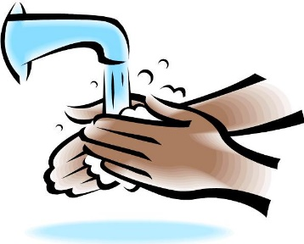
Use hand sanitiser gel if soap and water are not available.

NHS handwashing poster
NHS website

Taking care of your mental health and wellbeing

Keep in touch with people by phone, video chat or social media. Share any worries you have with others.
Stay connected with current events, but be careful where you get news and health information from. If news stories make you feel anxious, think about limiting what you look at for a while.
Plan your time - keep busy with activities around the house and time for things that help you feel relaxed.
UK Government advice for the public on the mental health and wellbeing aspects of coronavirus (COVID-19)
Mind Coronavirus and your wellbeing
Mental Health Foundation Looking after your mental health during the coronavirus outbreak
Swansea CVS Taking Care of Yourself in Challenging Times
Every Mind Matters England website

Look after your body
Our physical health has a big impact on how we feel. At times like these, it can be easy to fall into unhealthy patterns of behaviour. Try to eat healthy, well balanced meals, drink enough water, sleep well and exercise regularly. Avoid smoking or drugs and try not to drink too much alcohol.
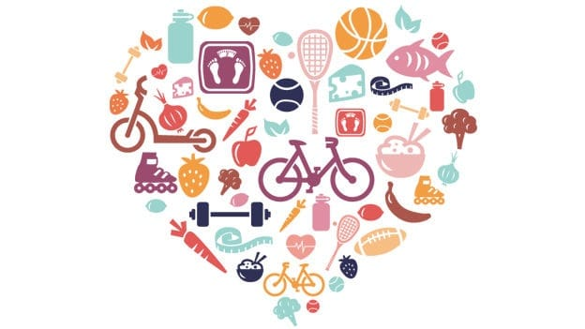
Build physical activity into your daily routine. Exercising at home can include:
- cleaning your home
- dancing to music
- going up and down stairs
- seated exercises
- online exercise workouts
- sitting less

NHS fitness studio has 24 instructor-led videos across our aerobics, exercise, strength and resistance, pilates and yoga categories. They also have other fitness plans including gym free workouts and sitting exercises.
Help Me Quit NHS Stop Smoking Service.
NHS Eat Well.
Change4Life resources include food facts, tips, sugar swaps, recipes, and activities to help families be healthier and happier.
British Dietetic Association Healthy eating: Food Fact Sheet.
Alcohol Concern interactive tools.
NHS Sleep and Tiredness.
Sport Wales keeping active

