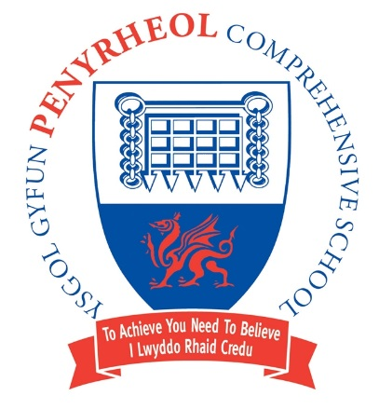
Headteacher/Pennaeth Pontarddulais Road

Damian Benney Gorseinon
SWANSEA
Tel: (01792) 533066 SA4 4FG
Fax: (01792) 533366

September 2023

Dear Parent/Carer/Pupil,
Swansea City AFC Foundation's PL Kicks initiative is a national programme that uses the power of football and sport to regularly engage children and young people of all backgrounds and abilities in football, sport and personal development – providing a trusted, positive influence in high-need areas. The project delivers free weekly sessions, giving young people aged 8-18 across South, West & Mid Wales the opportunities to play in football activities, whilst young people aged 16-25 have the opportunity to become volunteer officials or coaches.
Although the immediate emphasis of the programme is football, the Foundation coaches work in partnership with other local organisations to support young people with the challenges they face in their day-to-day lives and improve safety and community cohesion for their local neighbourhood. We work in partnership with Police Crime Commissioners, the South Wales Police, Dyfed-Powys Police, Youth Services, local councils, schools and other sports providers.
https://book.swanseacity.com/Home
Click on the link, then click on Premier League Kicks and look for the Gorseinon slot. This takes place at the Evolve Centre in the barn. Parents/Carers will need to make the booking.﻿
Tuesdays
5.00pm-6.00pm (Age 8-11)
6.00pm-7.00pm (Age 12-14)
7.00pm-8.00pm (Age 15-16)
Sessions will start on 3rd October 2023 and run weekly (except for school half terms) until 16th July 2024.
Yours sincerely,


Headteacher/Pennaeth
