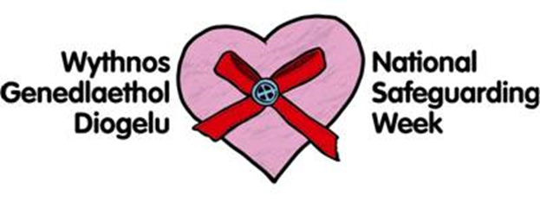

Dear Parents/Guardians,
In conjunction with this year’s National Safeguarding Week, Swansea Council are holding a pilot event at Penyrheol Leisure Centre Gorseinon, on Tuesday 12th November 2019 at 3.15pm-5.30pm. The event is for parents and guardians of pupils who attend Penyrheol Comprehensive School and for parents/guardians of children in years 5&6 of the local feeder primary schools. The aim is to provide you with information on current national and local safeguarding issues affecting children and young people in Wales including ‘County Lines’.
A number of different agencies will be present including Police, Education, Housing and Children’s Services and you will have the opportunity to ask questions and network. We hope to increase your awareness and understanding of children’s safety in the wider community, and offer advice on how you can help to keep your children safe.
Event Agenda
3.15 event opens – various information stalls to visit.
3.30 - 4.45 – safeguarding presentations from Police and Children’s Services. Topics include County Lines, Signs for concern and advice and support that is available.
If successful this safeguarding event may be rolled out to other schools across the West Glamorgan Regional Partnership area.
Light refreshments will be provided. We look forward to welcoming you.
West Glamorgan Safeguarding Board



