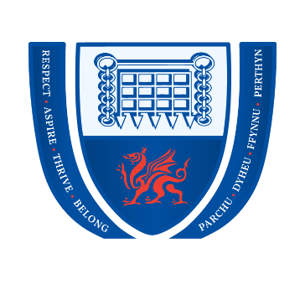
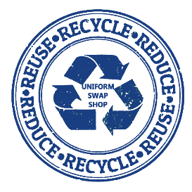
Penyrheol Comprehensive School
Uniform Swap Shop

ORDER FORM

Did you know you can request items of uniform from our shop for FREE?
Our donated and sometimes brand-new items are here waiting for you.
Donations of uniform that your child no longer fits are always welcome.
Thank you.

Pupil’s Name:
Pupil’s Form:
Contact Name & Number:

Uniform Required | Size | Quantity
Trousers
Skirts
Shorts
Sweat Shirts
Polo Shirts
PE Top
PE Shorts
PE Trainers
Rain Coat
Winter Coat

Send this form via email to FussellT1@hwbcymru.net , or return it to reception in person, during opening hours.

We will then prepare the items and contact you when they are ready to collect.

Be smart and help us to re-use, re-cycle and re-educate!

