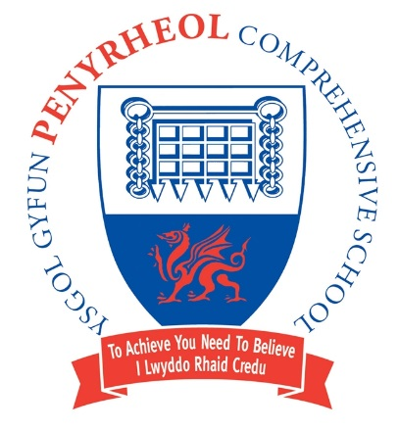
Headteacher/Pennaeth Pontarddulais Road

Damian Benney Gorseinon
SWANSEA
Tel: (01792) 533066 SA4 4FG
Fax: (01792) 533366

Headteacher’s Letter Friday 7th July (Letter 18)
Dear Parents/Carers,

This is the eighteenth Headteacher’s letter of this academic year. I trust these letters are keeping everyone informed about what is happening at Penyrheol School. This letter covers the last two weeks at Penyrheol.

Since the last Headteacher’s letter, we have had our first ever Health and Wellbeing day. We had over 60 people attending school from external agencies and FE to support the day. These agencies included Barnardos, CAMHS, the Fire Service and Barod. We had great feedback from our pupils on what was a very different and enjoyable day. We also had praise for our pupils from the external providers. We also enjoyed a superb Summer Concert on Thursday 29th June. Our pupils played to a capacity crowd in the theatre and it was an eclectic mix of music, delivered with skill and enthusiasm. We also had our cluster primary pupils performing too.
Some of our Year 9 and 10 pupils have enjoyed a trip to Glan Llyn outdoor pursuits centre. Our Year 10s enjoyed a taster day at Gower College on Tuesday of this week. The pupils did us proud and we had great feedback from the college lecturers. Year 8 pupils have visited the Brecon Beacons for their Geography field trip, Year 7 have had their sports day and Year 10 music students have had their Music performance exam. Today, some of our Year 9 boys took part in the CMET ‘Reach the Beach’ football tournament at Llangyfelach, playing against other Swansea schools’ Year 10 teams.
In the last two week we have also had our Year 6s up for 2 days of transition and yesterday we held a fantastic Year 6 football tournament on our 3G pitch. There was lots of skill and commitment from the pupils and the games were played in an excellent spirit. Congratulations to Pontybrenin for winning the trophy.

I would like to thank all parents/carers for their continued support.

Sport

Athletics
On 27th June, a number of pupils across Years 7 -10 competed at the Afan Nedd Tawe Inter-Schools Athletics Competition. There were some very strong performances across all teams, but the most notable performances of the day came from Sophia Edwards in the Junior Girls 300m, where she finished 1st in her heat and 4th in the final. The Junior Girls Relay Team consisting of Ellie Pennino, Sophie Pennino, Sophia Edwards and Amy Besley also qualified for the final. Well done to all the athletes who competed in their respective events!

Sports Ambassadors
Our Silver Sports Ambassadors (Annabel Williams, Ellie Pennino and Sophie Pennino) have been busy this term, organising a Sports Festival for a number of local Primary Schools. The event was held at the beginning of July at the Elba Sports Centre, supported by the Active Young Person’s Department. The event proved extremely successful and is testament to the continued effort and hard work shown by these pupils in their role.

Finally, well done to Declan Pearson, Joshua Paynter and Sophia Edwards on being selected to be Bronze+ Sports Ambassadors at Penyrheol.

Gymnastics
This weekend, four of our pupils, Megan Griffiths, Ava Williams, Valentina Sias and Holly Bamford, travel to Turin in Italy to represent their club and Wales in Sports Acrobatics. We wish them all the very best of luck in the competition!

Rounders
The year 9 rounders tournament at Pontarddulais was a huge success. The girls competed superbly and represented the school very well. They came 3rd in their pool.

Changes to Canteen Arrangements from September 2023

I have written to parents/carers about the above changes and all information is on the school website here.

It is vital that all parents/carers have completed this short survey otherwise their child will not be able to access the canteen from September.

https://forms.office.com/e/v9a9UPmtdc Can parents/carers complete the form ASAP if they haven’t already.

Battle of Llwchwr Cluster Project

Our STF pupils have been involved in cross cluster event called the Battle of Llwchwr. This event ties in with the ‘Cenefin’ aspect of the new curriculum. As part of this event, our pupils worked with Gower College staff and produced an incredible 3D scan of Oystermouth Castle. The link to their work is here. The project was an excellent example of partnership working as part of the new curriculum, DCF and Digital 2030.

Thursday 13th July- Industrial Action

I have written to parents/carers about the impact that next Thursday’s NASUWT strike is having on Penyrheol. Year 7 will be in school. Years 8 and 9 will be undertaking home learning. Year 10 will be on work experience as normal.

Yours faithfully,


Damian Benney
Headteacher

Appendix
What’s happening in the next two weeks:

Date | Event
Monday 10th July | Year 9 Geography Field Trip  Year 10 Work Experience Week
Tuesday 11th July | Year 9 Sports Day  Gower College Big Yellow Bus on site from 12:30pm to 2:30pm for Year 9 Pupils
Wednesday 12th July | Year 9 Art Optee’s Trip to Clyne Gardens
Thursday 13th July
Friday 14th July | Year 8 Sports Day
Monday 17th July | MFL/Welsh Department Trip to Normandy (returns on Thursday 20th
Tuesday 18th July | Summer Term Newsletter Published Online
Wednesday 19th July | Sports Day
Thursday 20th July | Years 7 and 8 Reports Issued  Activity Day
Friday 21st July | Summer Term Ends for Pupils

