
Headteacher/Pennaeth Pontarddulais Road

Damian Benney Gorseinon
SWANSEA
Tel: (01792) 533066 SA4 4FG
Fax: (01792) 533366

Headteacher’s Letter Friday 26th May (Letter 16)
Dear Parents/Carers,

This is the sixteenth Headteacher’s letter of this academic year. I trust these letters are keeping everyone informed about what is happening at Penyrheol School. This letter covers the last two weeks at Penyrheol.

Since the last Headteacher’s letter, the focus in school has very much been about GCSE exams for Years 10 and 11. I am writing this on Friday 26th may and this is the first day in 2 ½ weeks where we don’t have any GCSE exams. This means that Year 11 can really enjoy their last day at Penyrheol as their study leave starts after half term. It has been a bittersweet last day for our Year 11 pupils as so many are sad that their time here has come to an end. It has been a joy to see them having their shirts signed and to see the smiles and the laughter as they remember their time here. We ended this half term with a Staff v Year 11 pupils match which all pupils were invited to attend. The pupils won an entertaining game played in excellent spirit. The staff have some training to do for next year!!

At the end of this newsletter there are 2 flyers for activities during half term that our pupils can attend.

I would like to thank all parents/carers for their continued support.

Sport

Our Year 8/9 girls rugby team went to Bishopston on Wednesday 24th May for a touch rugby festival. They played four matches. They lost to Gwyr, drew with Bishopston and beat Morriston and Bryntawe. That’s a winning record!
Well played, girls. It is great to see the interest in what has always been a traditional male sport.
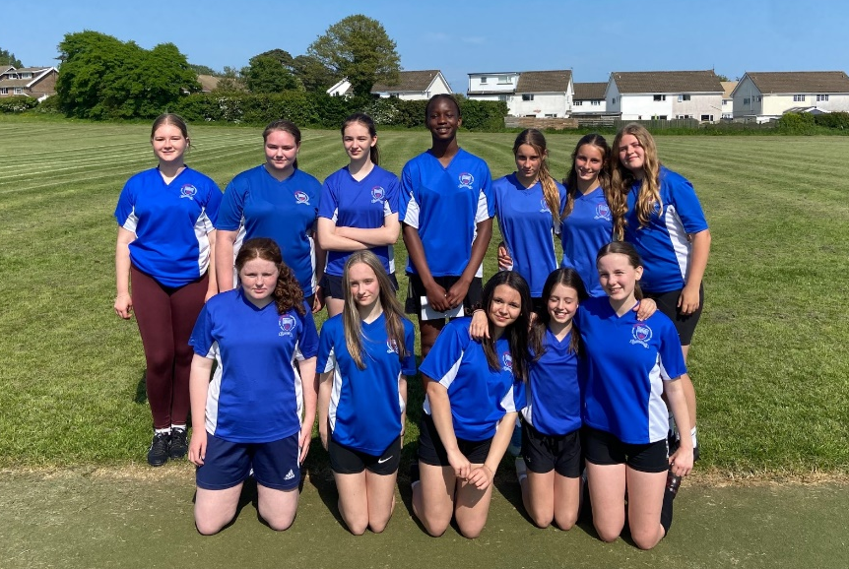

Standards
Attendance for the last 2 weeks has dropped to 83.6%. This dip coincides with the start of Year 11 GCSE exams. If you want to know your child’s attendance, the ClassCharts App has all the details. As always, if your child can be in school, please ensure that they attend.

These are our attendance award winners:

100% for May: | 100% from Sept to this half term
- 7E - Oliver Pyart | - 7E - Gioele Varesi
- 8E - Phoebe Whitlock | - 8U - Noah Raddenbury
- 9D - Callum Wright | - 9D - Joseph Salter
- 10R - Jasmine John | - 10C - Paulius Morkunas
- 11R - Lucy James | - 11S - Alex James

Winning forms

- 7E - 93%
- 8U - 90%
- 9H - 90%
- 10R - 92%
Penyrheol Values
In September 2023, Penyrheol Comprehensive School celebrates its 50th Birthday. This milestone gives us an opportunity to revisit our vision and our values so they better reflect the vision of the whole school community. I would like our core values to become part of Penyrheol's new corporate branding. We want to choose 4 words to describe the key values that we want our pupils to have or want them to be. These values will be key in us realising our school vision as they will underpin that school vision.
The words are grouped into 4 categories. Please can all parents/carers vote for their 2 favourite values in each group of words. We are asking our pupils and our staff to do the same.
Please see this video for more information:
https://www.loom.com/share/56070aacb26e4c4fb627a717f8f6b0f6

Here is the link to the survey:

https://forms.office.com/e/1aHZE7TJAG

I wish all our pupils and their families a happy, restful and safe half term break.

Yours faithfully,


Damian Benney
Headteacher
Appendix

What’s happening in the next two weeks:

Date | Event
Monday 5th June | Year 11 Study leave Starts  School Council Meeting (this week)
Tuesday 6th June
Wednesday 7th June | Transition Year 6 HA (Higher Attainers) Science Challenge
Thursday 8th June
Friday 9th June
Monday 12th June | Transition Year 5 Taster Morning
Tuesday 13th June | Transition Year 5 Taster Morning
Wednesday 14th June | Transition Year 5 Taster Morning
Thursday 15th June | Transition Year 5 Taster Morning
Friday 16th June | Transition Year 5 Taster Morning



