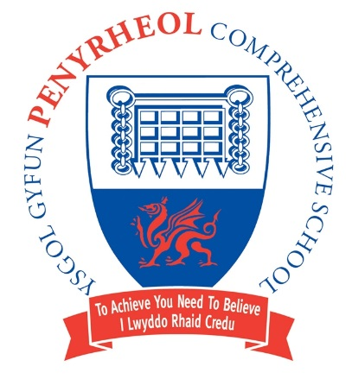
Headteacher/Pennaeth Pontarddulais Road

Damian Benney Gorseinon
SWANSEA
Tel: (01792) 533066 SA4 4FG
Fax: (01792) 533366

Headteacher’s Letter Monday 12th September
Dear Parents/Carers,

This is the first letter of what I hope will be more regular communication between myself and parents/carers to keep everyone informed about what is happening at Penyrheol School.

I trust this letter finds you well as pupils start their second week back after the summer break. It has been a joy to see our pupils return to school. They are ready for learning and are working hard to give themselves the chance to ‘be the best that they can be’ (Article 29). It has been a momentous week with the passing of Queen Elizabeth II. At the end of the letter, I have included the message we shared with our pupils on Friday morning. We have heard over the weekend that all schools across the UK will be closed on Monday 19th September for the funeral.

Results
There will be detailed results in the Governor’s Annual Report to Parents/Carers. Our headline figures included the fact that nearly a quarter of our Year 11 left with at least 5 A*/A grades at GCSE or equivalent and over three quarters left with at least 5 Cs (and above) GCSEs or equivalents. Schools are so much more than exam factories but we are delighted that so many pupils got the qualifications that the needed for the next stage in their educational/training/working journey.

Curriculum
This September sees the launch of the new Curriculum for Wales with our new Year 7 cohort. A huge amount of work has gone into the development of the Penyrheol Progression Curriculum in terms of purpose, content, skills, links and sequence. More details will be shared on our website in time. We are proud of how we have developed a knowledge rich curriculum and we believe that it will provide our learners with the knowledge, skills and experiences to realise the 4 purposes.

Parents’ Evenings
Over the last 2 years, Parents’ Evenings have been undertaken virtually. We are going to move forward with our Parents’ Evenings being a mix of face to face (in the theatre) and virtual. We will let Parents/Carers know well in advance. The Year 11 Parents’ Evening on Monday 3rd October will be face to face.

ClassCharts
As well as using the SchoolComms App (School Gateway), we will soon be launching a ClassCharts App for parents/carers. This App will give Parents/Carers real time achievement and behaviour data so you will be better informed about how your child is getting on. It also has a wellbeing function. We will make videos to help parents/carers get the most out of the App.

Standards
I must take this opportunity to formally thank the parents/carers of the Penyrheol School community for ensuring that their children are ready for school. School uniform is looking smart and we have close to 99% of our pupils in full school uniform. In the few cases where uniform isn’t fully correct, these are being followed up on an individual basis. It has been notable that the vast majority of our pupils have shown impeccable manners since returning to school. I don’t think I have ever known a return to school accompanied by so many friendly, polite and respectful interactions between pupils and staff. Long may that continue. Attendance last week was 94.6%.

New Rules
We have introduced or tweaked a few rules for the start of September. I am making a video for parents/carers to watch where I clarify the what and the why of the new rules for September 2022. I will send this out later in the week.

Yours faithfully,

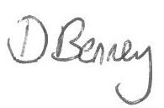

Damian Benney
Headteacher

Appendix

What’s happening in the next two weeks:

Date | Event
Monday 12th September | Year 7 All Wales Reading Test (this week)  Year and School Council Elections (this week)
Tuesday 13th September | Senior Leadership Team Meeting (3:10pm)
Wednesday 14th September | Year 9 ‘Have a Go’ Enterprise Introduction session for 30 pupils (12:20pm)
Thursday 15th September
Friday 16th September | Year 7 and Year 10 Photographs (Lessons 1-4)
Monday 19th September | Closed for Queen Elizabeth II Funeral
Tuesday 20th September | School Council Meeting (this week)
Wednesday 21st September | Key Stage 4 Construction Visit to Local Encon Site
Thursday 22nd September | Year 7 Music Enrichment Day (rearranged)  Year 10 Open Evening (5:00pm – 6:00pm)
Friday 23rd September
Penyrheol School Statement on the passing of Queen Elizabeth II
I am sure that all pupils are aware that Queen Elizabeth II died yesterday. Without question, this is a significant event in the History of Great Britain. Queen Elizabeth II was the longest serving monarch and was our head of state for over 70 years. 15 Prime Ministers have come and gone during her reign.
The concepts of monarchy, the commonwealth and empire are indeed complicated. This is one of the reasons why education is so valuable; you can learn about them and form your own opinions. But today is not the day for opinions. Today is the day for showing respect. Queen Elizabeth II was a mother, a grandmother and great grandmother. She has given 70 years of service to the country, in a role that she didn’t have the luxury of choosing. She worked right up until her passing. She also carried her reign with humility, dignity and grace.
For every member of staff and every pupil at Penyrheol, the Queen has been a constant in our lives. Her picture is on banknotes, stamps and post boxes. All that will change with Prince Charles becoming King.
But today is a day that the country remembers the Queen and we thank her for 70 years of service.

